Assignment – 1

1. **User Login**

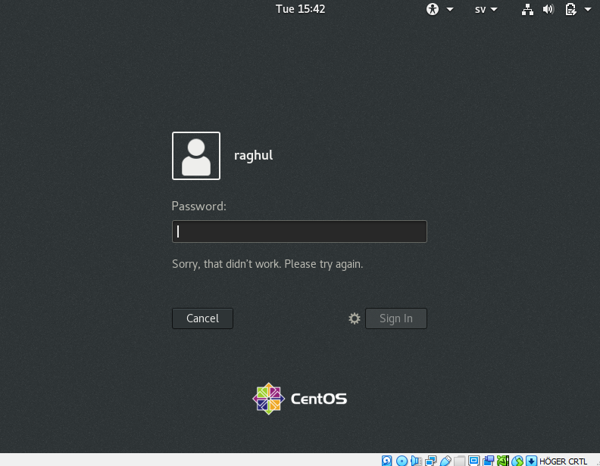

**Explanation**: When an unknown user or if user enters wrong password the authentication fails.

1. **Password change**

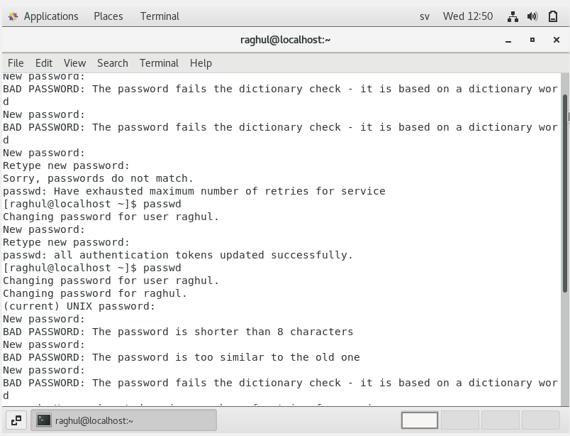

**Explanation:** As mentioned in the above screenshot if the password passes the Linux dictionary check, its updated as the current password or else it states that it failed the dictionary check

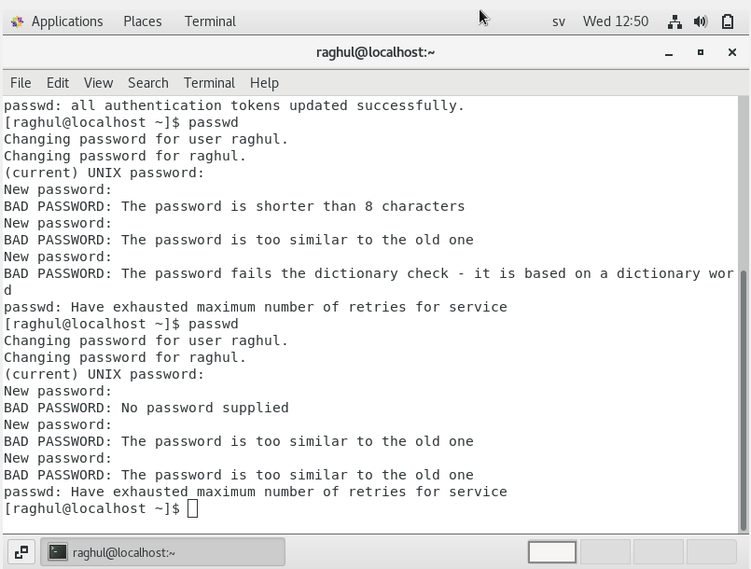

**Explanation**: when tried adding the password 1234, it shows its shorter than 8 char and if the password does not have numbers or special characters in the string, then password fails the dictionary check.

3. **working with directories**:

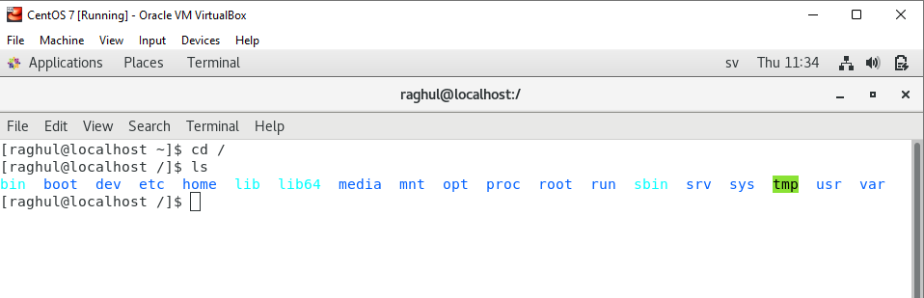

/ - is the root directory

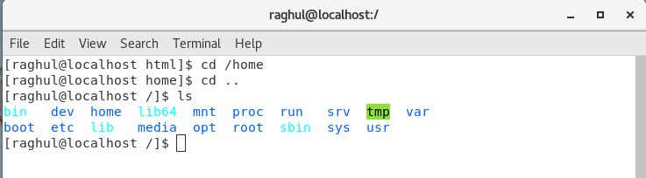

/ home – This is the login directory and this where we store individual files and folders.



Cd .. – takes you back to the previous directory.

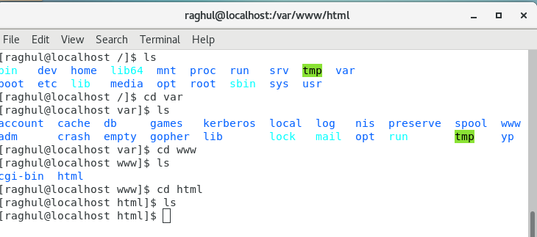

**var/www/html** is just the default root folder of the web server.

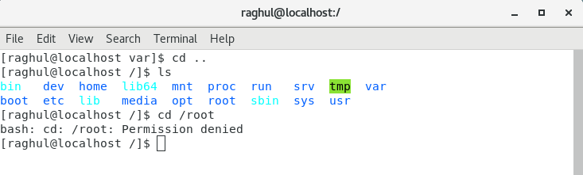

The local user cannot login to the root directly.

**4. working with directories:**

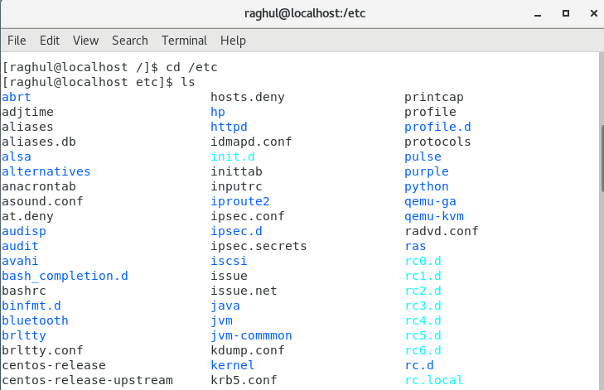

**cd /etc –** contains all the config files of the linux

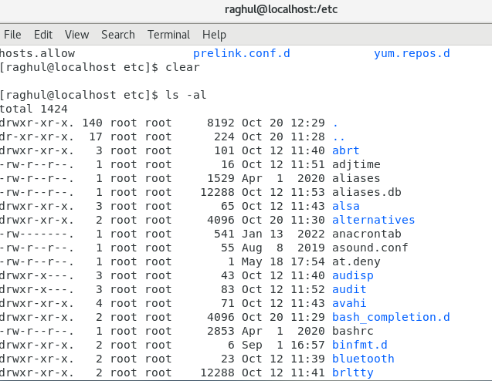

**ls -al** defines all the files that has read, write access.

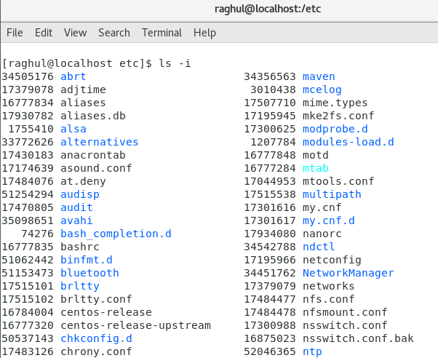

**ls -I** prints the index number of each file.

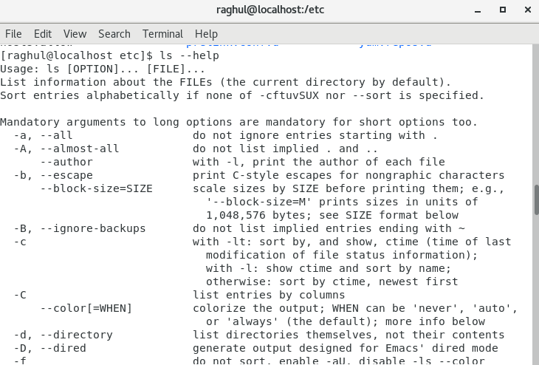

**ls –**help lists the combination of each commands within the ls command.

5**. Know where you are and where you working**

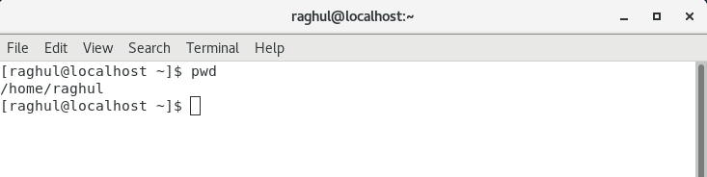

**Pwd –** shows the current location from the initial folder level. Also when the terminal is closed and reponed, we can find ourselves in the home directory.

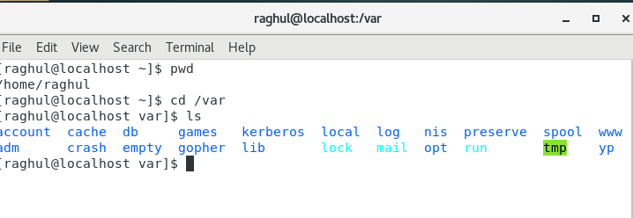

**Cd/var** – var is also known as variable because it holds variable data such as logs, temp files, crash data etc.